COURSE CODE : ITA1430
COURSE NAME : ETHICAL HACKING

EXPERIMENT – 9
Nmap Timing and Performance Commands
Aim
To perform IDS evasion and timing scans using Nmap.
Theory
Timing options control the speed and stealthiness of Nmap scans.
Commands
i) Polite IDS Evasion
nmap -T2 192.168.1.10
Description:
Slows down scanning to reduce the chance of detection.
ii) Normal Scan
nmap -T3 192.168.1.10
Description:
Default balanced scanning speed.
Procedure
- Identify target IP address.
- Execute Nmap timing commands.
- Observe scan duration and results.
- Compare scan speeds.

Output:
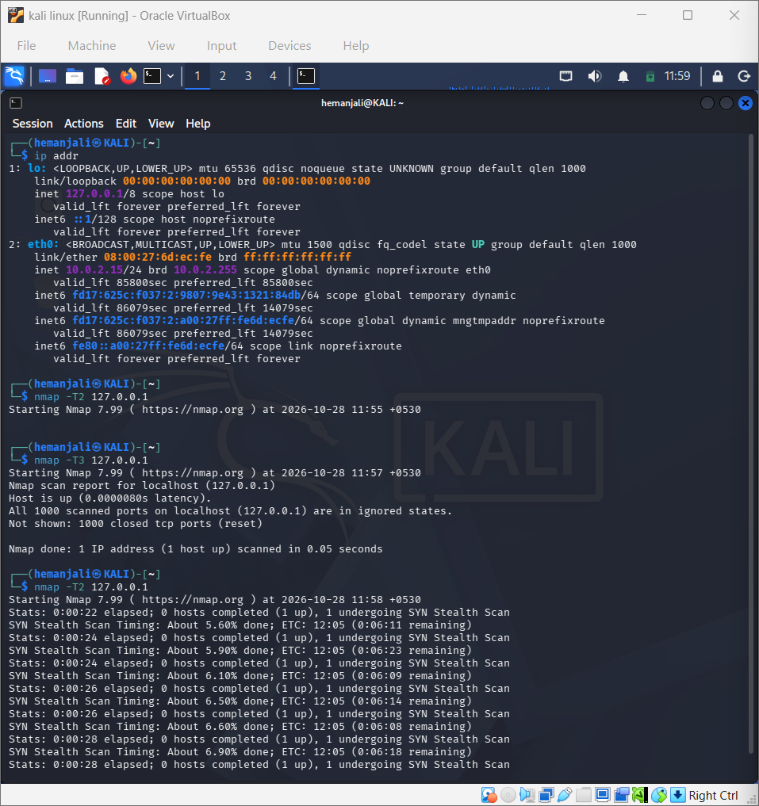
Result
Successfully executed Nmap timing and performance scans in Kali Linux.

